Scalpify Mobile App
Screen Walkthrough

This document accompanies the FYP report and walks through the thirteen principal screens of the Scalpify mobile application as captured on iPhone. Each entry pairs the rendered screenshot with a description of what the patient sees, what each control does, and how the screen ties into the FastAPI backend and the on-device data layer. Screens are ordered to follow the natural user flow: first-time onboarding, scan capture, analysis review, the long-running recovery surfaces, and the account-management tail.

01 — Welcome / Splash
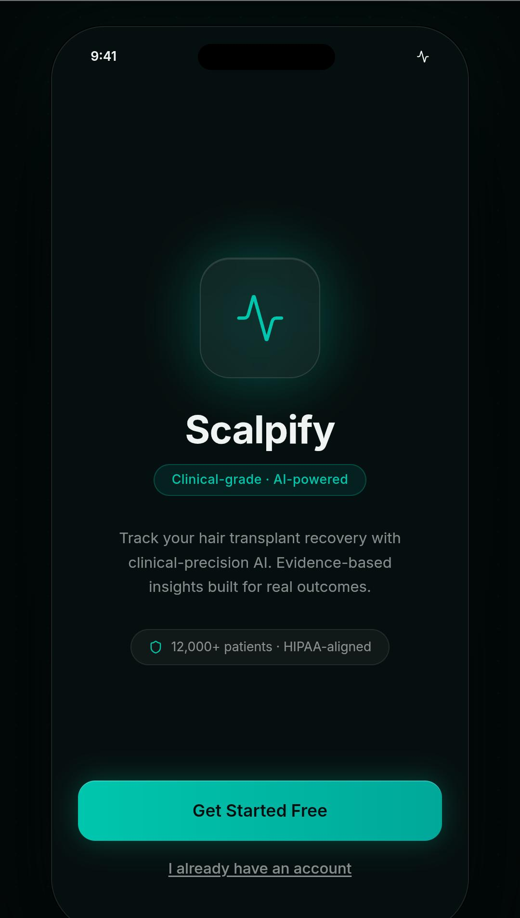 | What's on this screen. The first screen the patient sees on a fresh install. A glowing teal Scalpify mark sits at the centre of a dark canvas, with a single-line tagline (Clinical-grade · AI-powered) and a short value statement underneath. A trust badge near the bottom reads 12,000+ patients · HIPAA-aligned.  What happens here. Two actions are exposed. Get Started Free is the primary call-to-action and routes a brand-new user to the Sign-Up flow. The smaller text link I already have an account routes a returning user to Sign-In. The Splash screen also reads the locally stored profile from AsyncStorage on launch; if a profile is found, this screen is skipped entirely and the user lands directly on the Home dashboard.

02 — Sign In
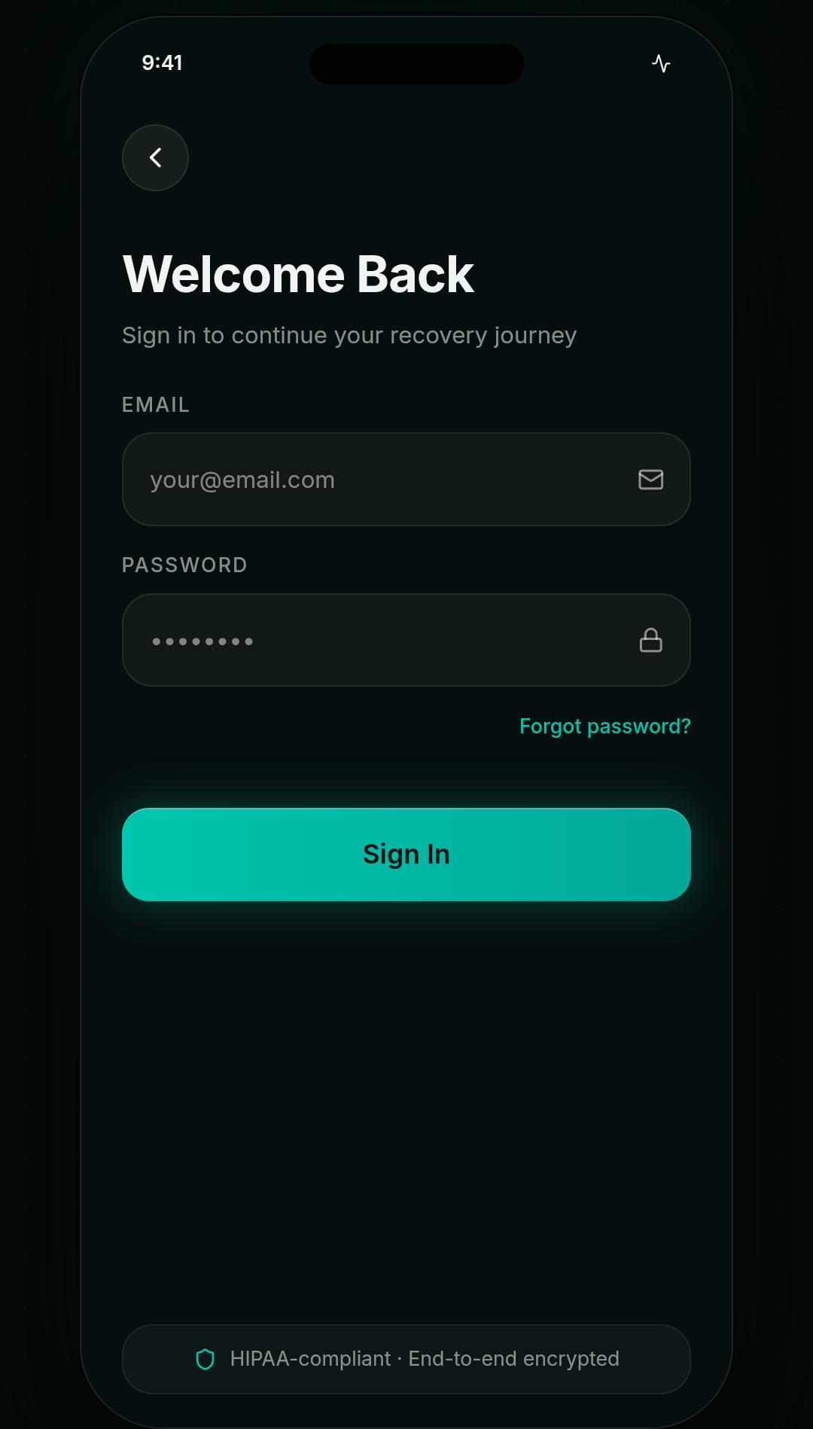 | What's on this screen. The Sign-In screen for returning users. A back button in the top-left returns to Splash. The heading Welcome Back is paired with the supportive sub-headline Sign in to continue your recovery journey. Two labelled inputs are presented — Email and Password — each rendered as a rounded dark capsule with a soft glyph on the right (envelope and padlock). A Forgot password? link sits beneath the password field, and the bottom of the screen carries a trust badge: HIPAA-compliant · End-to-end encrypted.  What happens here. The primary teal Sign In button submits the credentials. In the current build the email is matched against the locally stored profile in AsyncStorage; the password field is captured but not yet validated against a remote identity provider — full Supabase Auth integration is scoped for a future release.

03 — Sign Up — Create Account
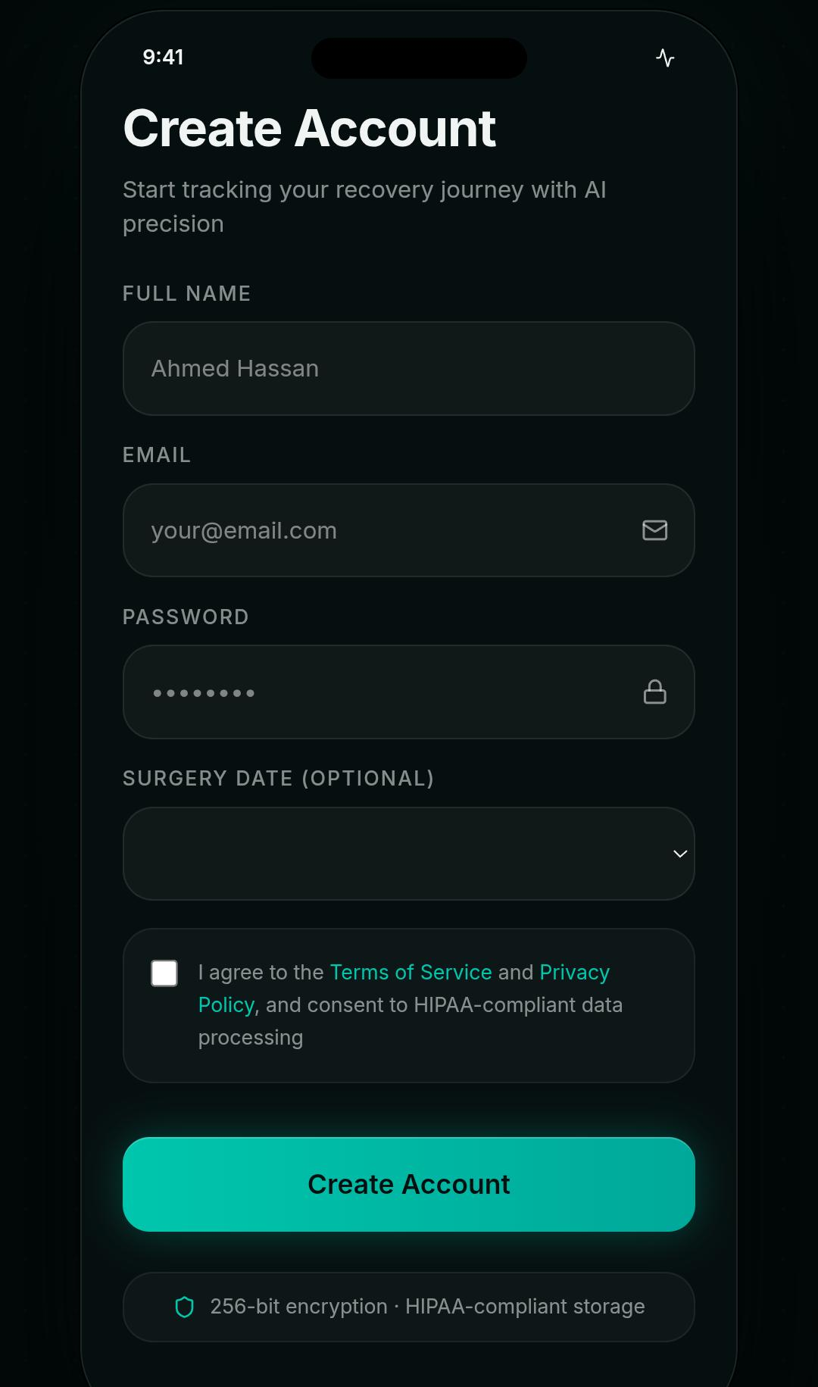 | What's on this screen. The Sign-Up screen for first-time patients. A four-field form collects Full Name, Email, Password, and an optional Surgery Date. A consent checkbox at the bottom confirms agreement to the Terms of Service and Privacy Policy and explicitly mentions HIPAA-compliant data processing. A footer reassures the user: 256-bit encryption · HIPAA-compliant storage.  What happens here. Tapping Create Account writes a new UserProfile to AsyncStorage under the key scalpify.user.v1, including a generated identifier of the form u_<base36-timestamp>_<random>. The surgery date drives the day-zero marker on the recovery calendar; if the user leaves it blank, the calendar defaults to displaying the current day as day 1. After submission the user is routed to the Home dashboard.

04 — Home Dashboard
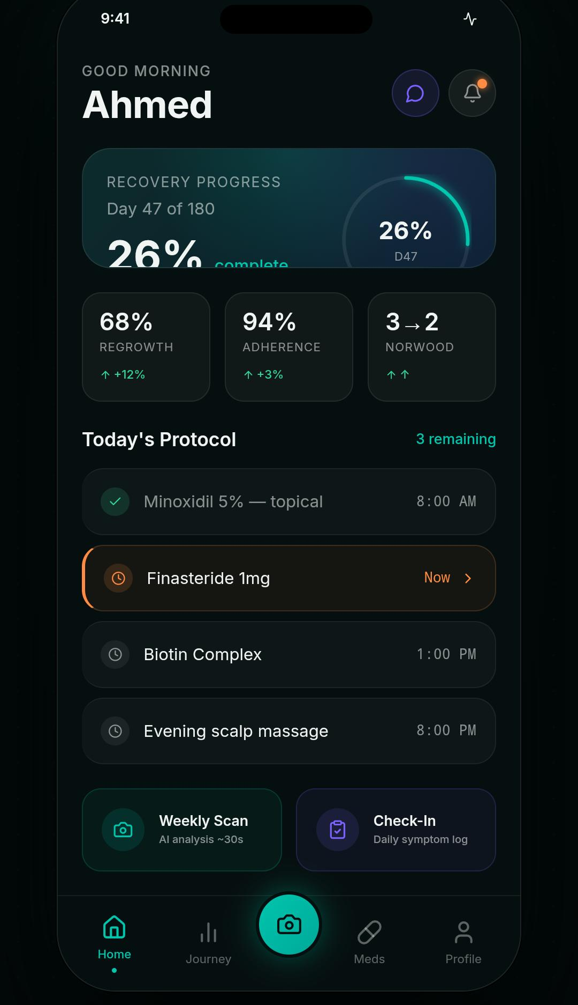 | What's on this screen. The daily landing page. A personalised greeting (Good Morning, Ahmed) sits at the top alongside a quick-access chat affordance and a notification bell with an active-alert dot. The Recovery Progress card renders a teal arc gauge showing Day 47 of 180 and the headline 26 % complete. Three small metric tiles underneath summarise Regrowth (68 % ↑+12 %), Adherence (94 % ↑+3 %), and the Norwood delta (3 → 2 ↑↑). Today's Protocol is laid out as a checklist: a completed Minoxidil 5 % topical at 08:00, a Now-flagged Finasteride 1 mg at 09:00 (highlighted in amber), and two scheduled items (Biotin Complex at 13:00 and an Evening scalp massage at 20:00). The footer carries a Weekly Scan shortcut and a Check-In daily symptom logger. The bottom tab bar exposes Home, Journey, the central camera FAB, Meds, and Profile.  What happens here. The floating teal camera button is the entry point to the analysis pipeline. Tapping it opens the Camera screen. The Weekly Scan tile is a secondary route to the same flow and includes the latency hint AI analysis ~30s. Each protocol row in Today's Protocol is interactive: tapping a pending row marks the medication as taken and updates the adherence metric on the next render.

05 — Camera — Scan Capture
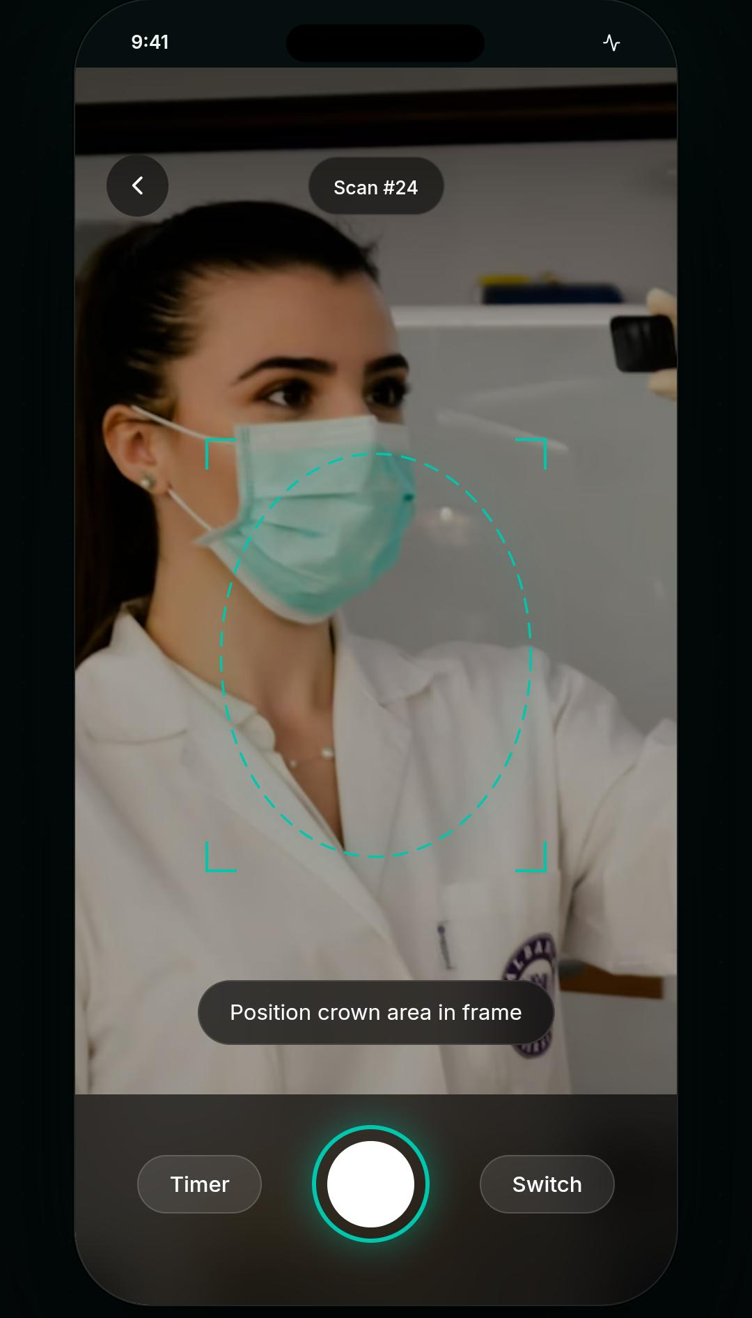 | What's on this screen. A full-screen capture surface for the scalp photo. A circular reticle with right-angle corner markers floats over the live camera preview and a top-centre pill displays the running scan counter (Scan #24). A back button in the top-left exits without capturing. A tooltip near the bottom reminds the user: Position crown area in frame. The bottom control row carries a Timer toggle on the left, a large teal shutter button in the centre with a soft glow, and a Switch (front/back camera) control on the right.  What happens here. Capture uses expo-camera. After the shutter is pressed the captured image is re-encoded to JPEG at quality 0.92 and resized so that the longest edge is at most 1600 pixels (via expo-image-manipulator). The resulting JPEG is then posted as multipart/form-data to POST /api/v1/analyze on the FastAPI backend. The Timer control introduces a configurable countdown for hands-free capture; the Switch control toggles between rear and front-facing cameras.

06 — Journey — Density Score and Recovery Timeline
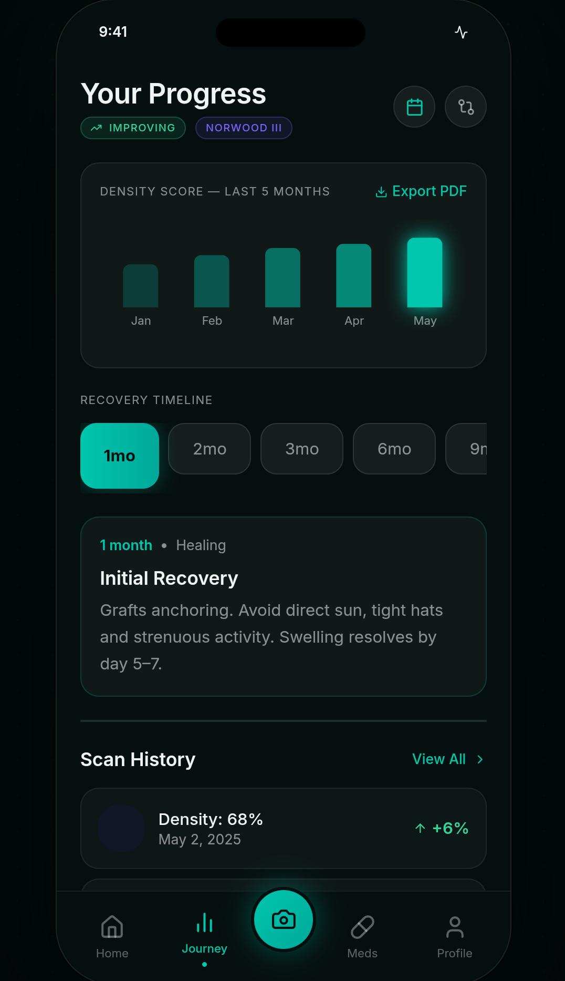 | What's on this screen. The Journey tab summarises the patient's tracked progress. The header Your Progress carries two status pills: a green IMPROVING badge and a purple Norwood III badge. The Density Score card is a five-bar chart (Jan through May) showing month-on-month growth, with the most recent month rendered as a glowing teal bar. An Export PDF action sits in the card header. Beneath the chart, the Recovery Timeline switcher exposes five horizontal chips — 1 mo, 2 mo, 3 mo, 6 mo, 9 mo — with the active chip highlighted in teal. The selected month surfaces a contextual card (1 month · Healing — Initial Recovery — Grafts anchoring. Avoid direct sun, tight hats and strenuous activity. Swelling resolves by day 5–7). The Scan History strip at the bottom previews the most recent scans with their density readings and the delta from the previous scan.  What happens here. The bar chart is generated from the array of AnalysisResult rows stored in Supabase; the most recent bar always glows. The horizontal chip row is scrollable; tapping any chip replaces the contextual card with the corresponding educational copy for that recovery phase. Export PDF serialises the patient's full progress record to a shareable PDF, intended for forwarding to a clinician.

07 — Journey — Dormant Phase (3-month view)
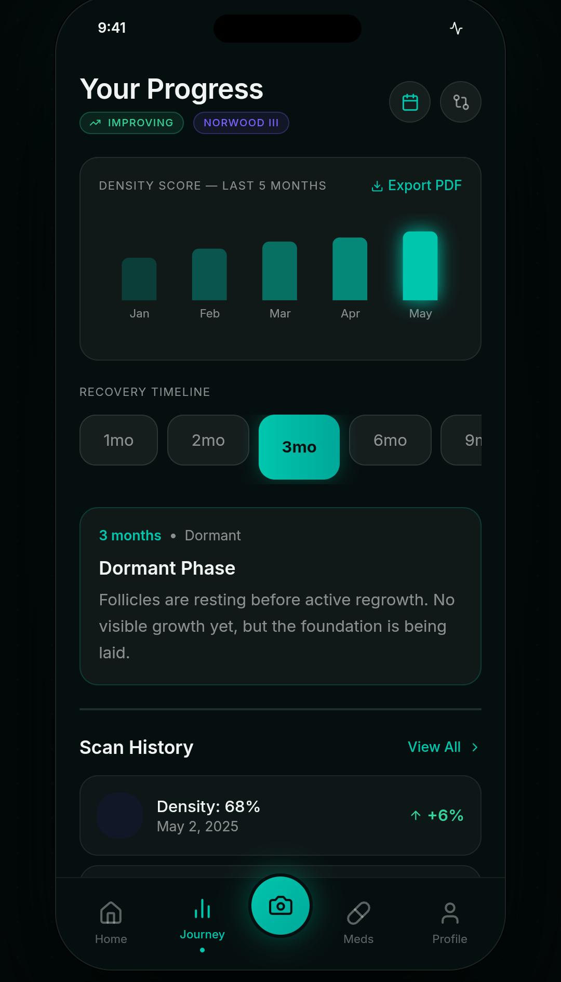 | What's on this screen. The same Journey screen with the 3 mo timeline chip selected. The contextual card now reads 3 months · Dormant — Dormant Phase — Follicles are resting before active regrowth. No visible growth yet, but the foundation is being laid. The visual cue around the chip shifts from a flat pill to a glowing teal block to indicate selection.  What happens here. This view illustrates how the contextual copy adapts to each phase. All four core phases (Initial Healing, Shedding, Dormant, Active Regrowth) carry distinct copy keyed to the patient's actual recovery timeline; clinicians have asked for the dormant-phase reassurance specifically because it is the phase patients most often misread as procedure failure.

08 — Norwood Analysis (Modal)
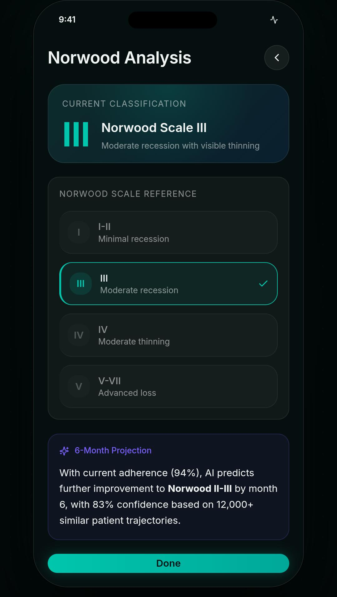 | What's on this screen. A modal sheet opened from the Norwood badge on the Scan Results screen. The Current Classification card renders the patient's stage in large numerals (Norwood Scale III) with the descriptive tag Moderate recession with visible thinning. Beneath it sits a Norwood Scale Reference with four anchor rows — I-II (Minimal recession), III (Moderate recession, marked active), IV (Moderate thinning), and V-VII (Advanced loss). At the bottom an AI 6-Month Projection card forecasts further improvement to Norwood II–III by month 6 with 83 % confidence based on 12,000+ similar patient trajectories. A teal Done button dismisses the modal.  What happens here. The Norwood classification comes from the /api/v1/analyze response: the backend maps the computed baldness ratio to a Norwood band using the thresholds <15 % I-II, <30 % III-IV, <50 % V-VI, ≥50 % VII. The 6-Month Projection is a marketing-facing summary in the current build; a fully personalised projection model is documented in the future-work section of the FYP report.

09 — Recovery Calendar
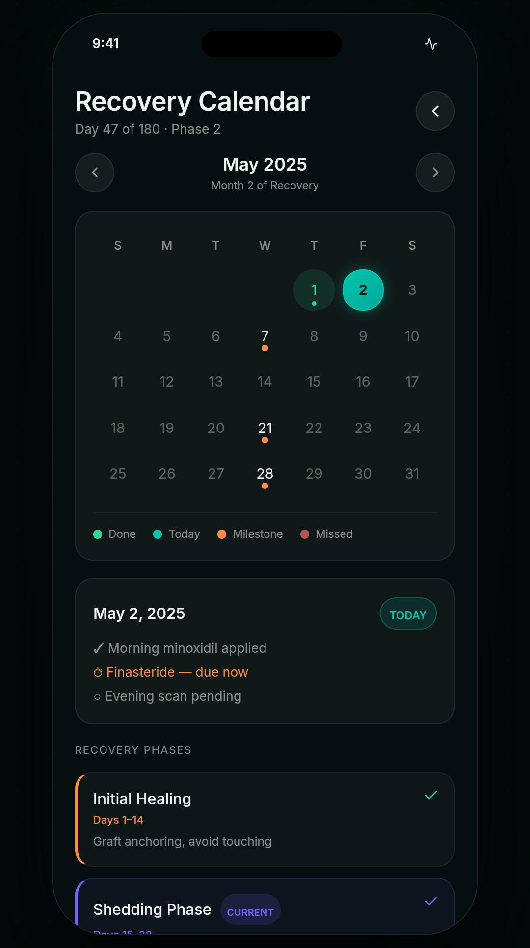 | What's on this screen. A month-grid recovery calendar that anchors every reminder to the patient's surgery date. The header reads Recovery Calendar with the subtitle Day 47 of 180 · Phase 2. A month-stepper exposes left/right chevrons around the active month label (May 2025 · Month 2 of Recovery). The calendar grid colour-codes each day: the active day pulses teal (May 2), prior days carry small dots that map to Done, milestone days are flagged in amber, and missed days appear in red. A four-key legend (Done, Today, Milestone, Missed) sits below the grid. A day-detail card for May 2, 2025 shows the day's protocol items: ✓ Morning minoxidil applied, ⊙ Finasteride — due now (in amber), ○ Evening scan pending.  What happens here. Tapping any day on the grid swaps the day-detail card to that day's schedule. Days before today render with their actual logged outcome; days after today preview the scheduled protocol. The Recovery Phases section below the day-detail (see the next screen) provides a high-level timeline of the four recovery phases.

10 — Recovery Phases and AI Recovery Projection
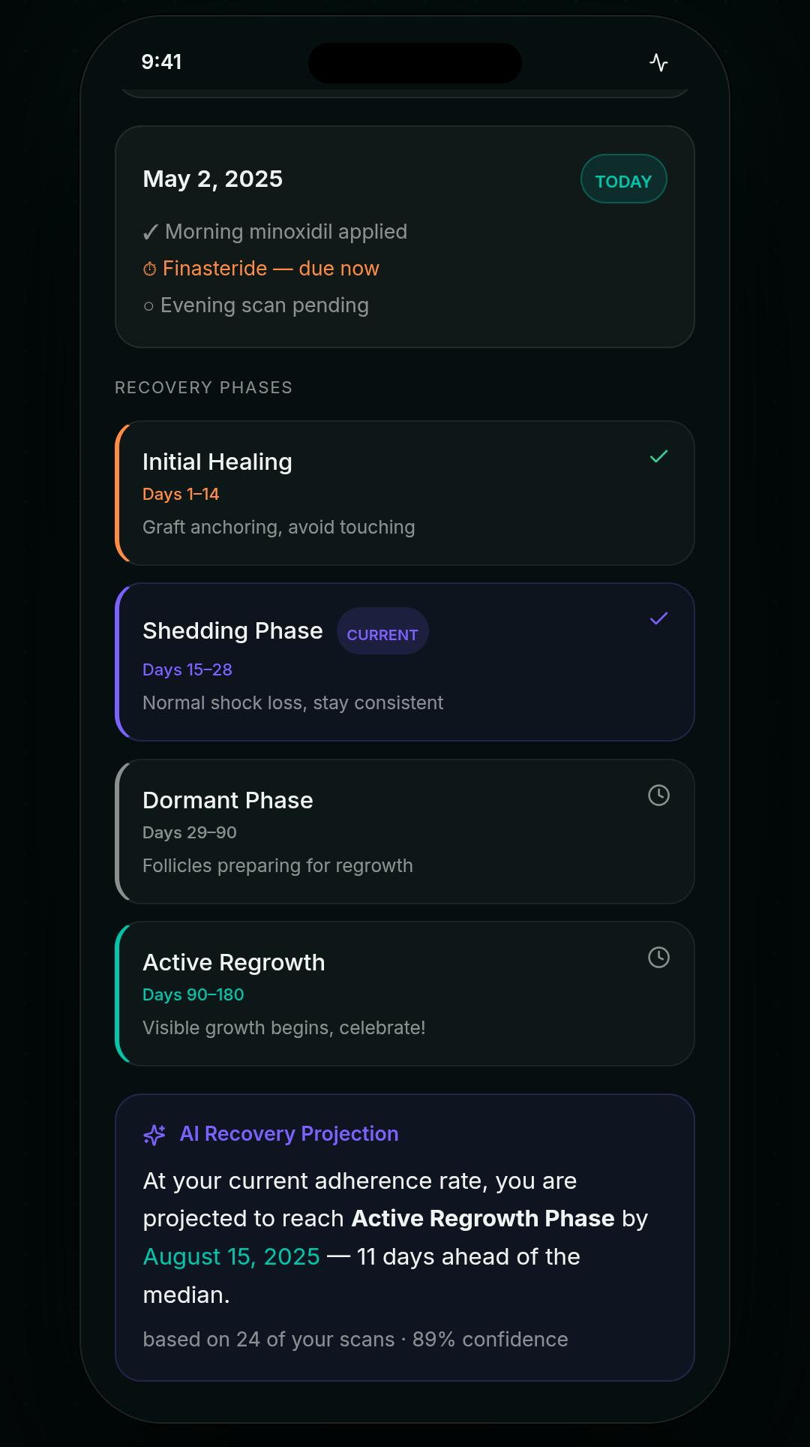 | What's on this screen. The lower portion of the Recovery Calendar. Four phase cards describe the patient's complete six-month recovery in plain language: Initial Healing (Days 1–14 — Graft anchoring, avoid touching) shown with a green tick because the patient has cleared it; Shedding Phase (Days 15–28 — Normal shock loss, stay consistent) flagged as the CURRENT phase with a purple accent; Dormant Phase (Days 29–90 — Follicles preparing for regrowth) pending; and Active Regrowth (Days 90–180 — Visible growth begins, celebrate!) pending. Beneath the phase list an AI Recovery Projection card forecasts that, at the current adherence rate, the patient is projected to reach Active Regrowth Phase by August 15, 2025 — eleven days ahead of the median, with 89 % confidence based on the 24 logged scans.  What happens here. The CURRENT pill marks the phase whose date range contains today. The projection date is calculated from the patient's adherence rate, their surgery date, and the population median; the eleven-days-ahead framing is intentionally encouraging without being prescriptive.

11 — Medications
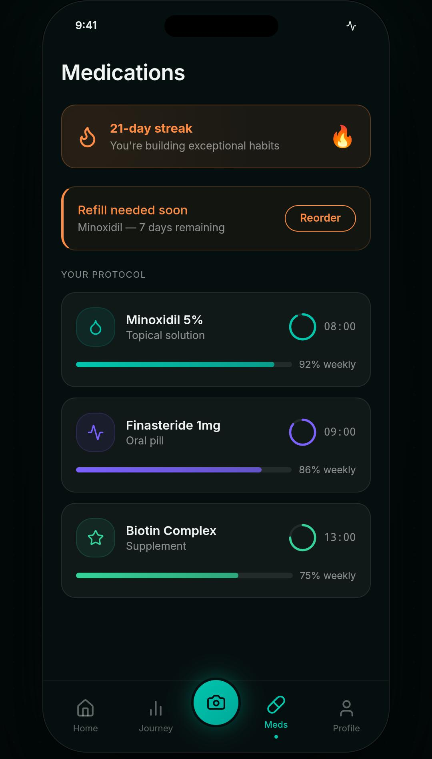 | What's on this screen. The Meds tab. A 21-day streak banner at the top celebrates the patient's consistent medication adherence (You're building exceptional habits) with a fire icon. A second banner flags an upcoming supply issue: Refill needed soon — Minoxidil — 7 days remaining, with a Reorder action. Your Protocol lists the patient's active medications as full cards: Minoxidil 5 % (Topical solution, 08:00, 92 % weekly), Finasteride 1 mg (Oral pill, 09:00, 86 % weekly), and Biotin Complex (Supplement, 13:00, 75 % weekly). Each card carries a colour-coded icon, the scheduled time, an inner progress ring summarising the weekly adherence percentage, and a horizontal progress bar.  What happens here. Adherence is computed locally in the medsStore from the patient's check-offs on Today's Protocol on the Home dashboard. The Meds tab supports add, edit, and swipe-to-delete operations on individual medications; new medications are written to scalpify.meds.v1 in AsyncStorage. The streak counter increments by one for every day on which all scheduled medications were marked taken.

12 — Profile — Top section
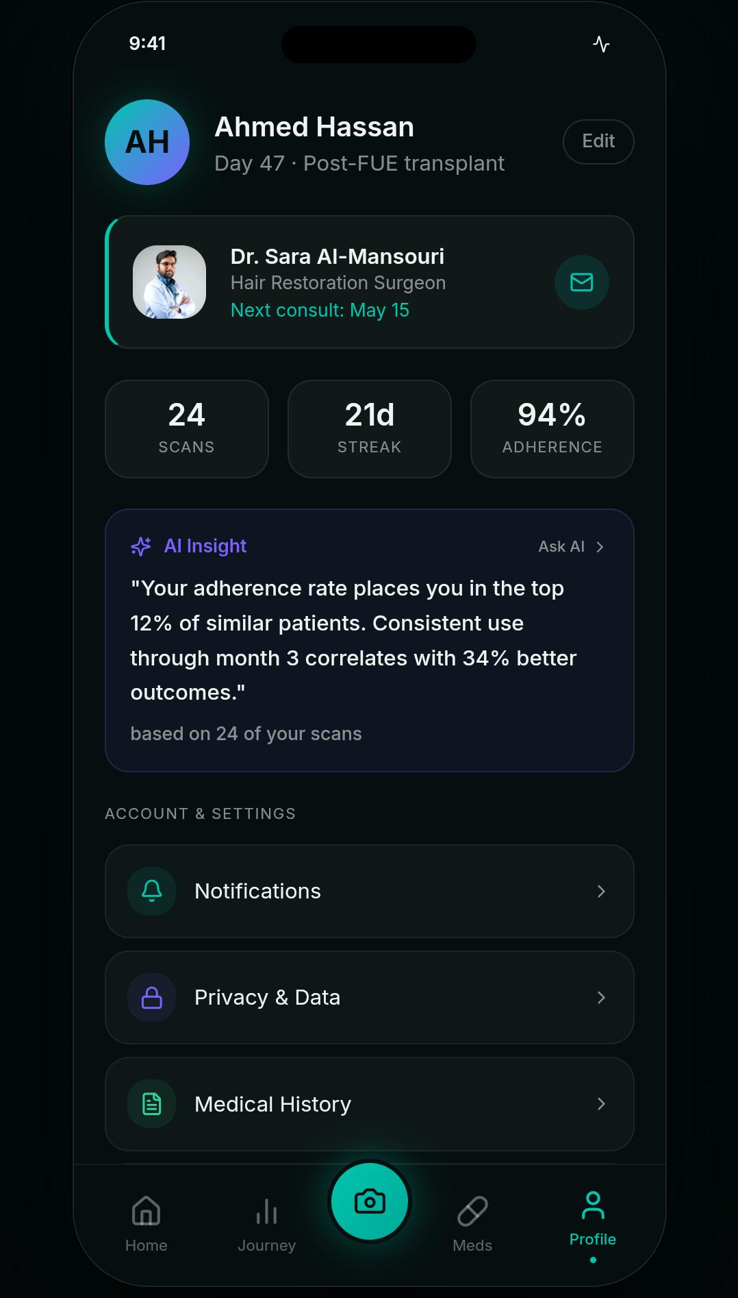 | What's on this screen. The patient's Profile tab. A large circular avatar with the patient's initials (AH for Ahmed Hassan) and a teal-purple gradient sits alongside the patient's name and the subtitle Day 47 · Post-FUE transplant. An Edit button on the right opens the profile-editing modal. Below the header is a clinician card linking the patient to their treating practitioner: Dr. Sara Al-Mansouri — Hair Restoration Surgeon — Next consult: May 15, with a tap-to-message envelope icon. A three-card metric strip shows the patient's lifetime totals: 24 scans, 21-day streak, and 94 % adherence.  What happens here. The clinician card is informational in the current build; in-app messaging is scoped for a future release. The scans count is read directly from the count of AnalysisSession rows that belong to the patient; the streak and adherence values mirror the Meds tab.

13 — Profile — AI Insight and Settings
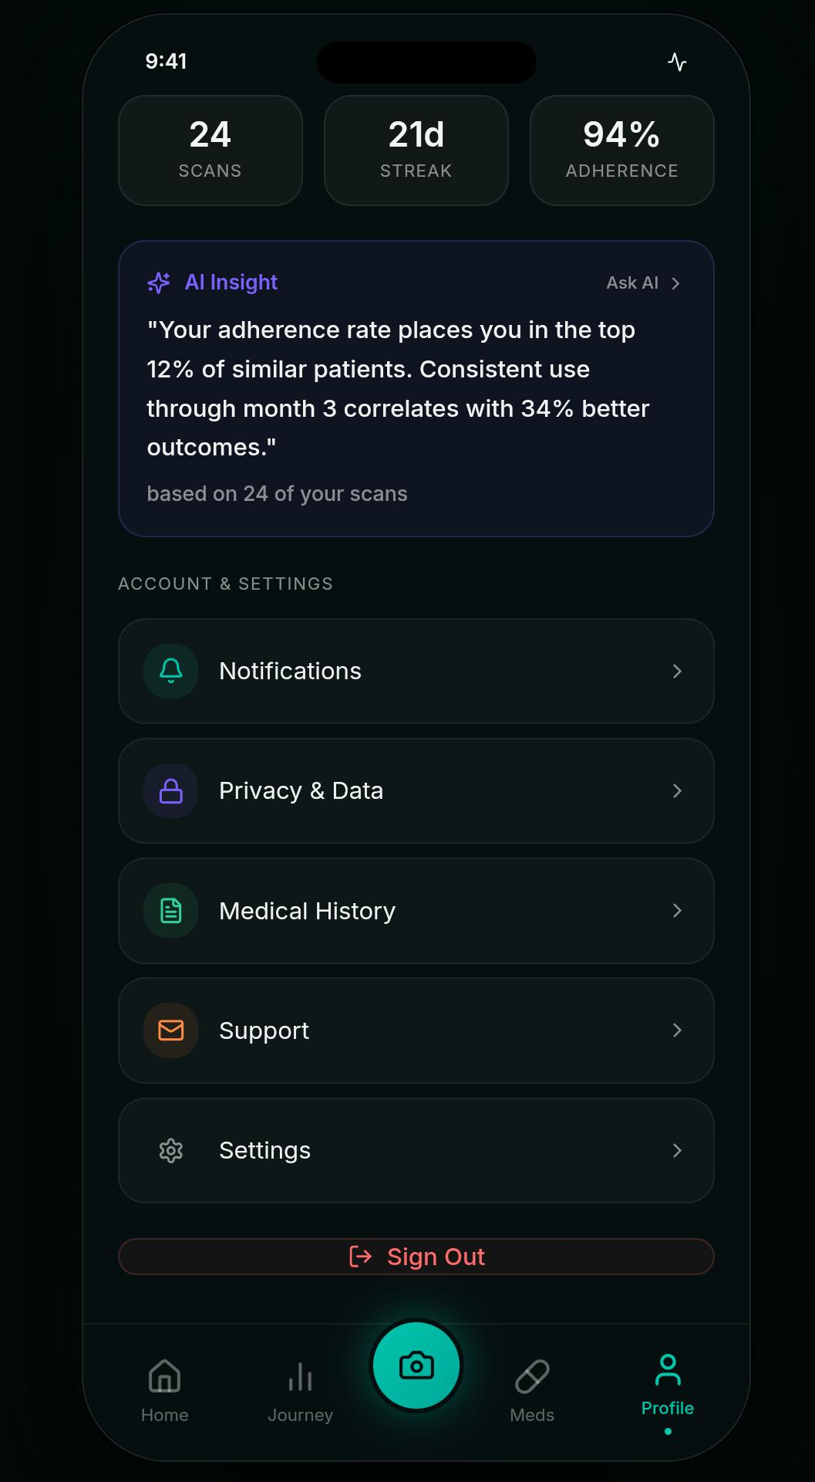 | What's on this screen. The lower half of the Profile screen. A purple AI Insight card summarises the patient's standing relative to the population: Your adherence rate places you in the top 12 % of similar patients. Consistent use through month 3 correlates with 34 % better outcomes — based on 24 of your scans. A small Ask AI shortcut in the card header previews an in-app assistant. The Account & Settings list exposes five rows: Notifications, Privacy & Data, Medical History, Support, and Settings, each rendered with a coloured glyph and a chevron. A red Sign Out action sits at the foot of the screen.  What happens here. Sign Out clears the persisted profile from AsyncStorage and routes the user back to the Splash screen. The AI Insight card and the Ask AI affordance preview an in-app retrieval-augmented chatbot that is documented in the future-work section of the FYP report. Privacy & Data is the entry point for the export-my-data and delete-my-account flows once those are implemented.

Where a screen surfaces a feature that is anticipated rather than delivered in the current build — the in-app chatbot, the clinician messaging path, the export-my-data flow — that distinction is captured in the future-work section of the main FYP report. Every screen shown above is reachable in the running application.

